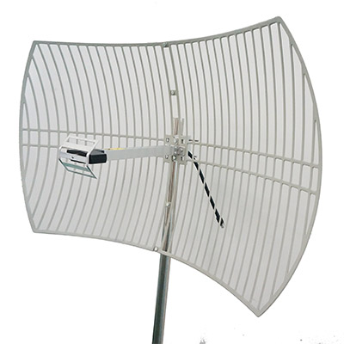
Product name: 0.9m 2.4GHz Parabolic Antenna
Product model: GL-DY2425V24
Applications:
2.4GHz, WLAN, WIFI Wireless System
Point-to-point, point-to-multipoint systems
Features:
High gain, high front-to-back ratio
Anti-aging Surface Coati
Electrical Specifications
Frequency Range-MHz | 2400-2500
Polarization | Vertical
VSWR | ≤1.5
Gain-dBi | 24
Horizontal beam width | 10°
Vertical beam width | 14°
Front-to-back ratio-dB | ≥30
Input Impedance-Ω | 50
Maximum input power-W | 100
Lightning protection | DC Ground
Mechanical Specifications
Input connector type | N-K
Dimensions-m | 0.9×0.6
Antenna weight-kg | 3
Reflector material | Aluminum
Reflecting surface color | Gray
Mechanical tilt | 0～20°
Operating temperature | -40°C to + 65 °C
Rated Wind Velocity-m/s | 60
Mounting hardware - mm | φ35～φ50

