Product name:Hand Held Antenna
Product number:GL136UV2
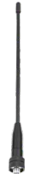
Item | Hand Held Antenna
PN | GL136UV2
Frequency Range (MHz) | 136-174/400-470
Impedance (Ω) | 50
V.S.W.R | ≤ 1.5
Gain (dBi) | 2
Connector | SMA-K
Length-mm | 200
Weight | 15g

