GLOBAL EAST ASIA TECHNOLOGY CO.,LTD

3G Yagi Antenna
GL1722V-10

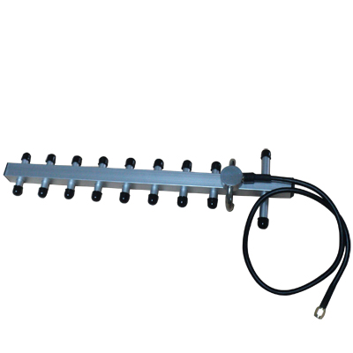

Electrical Specifications
Frequency Range | 1710-2170MHz
VSWR | ≤1.5
Gain | 10dBi
Horizontal beam width | 30°
Vertical beam width | 30°
Front-to-back ratio | ≥16dB
Polarization | Vertical
Input Impedance | 50Ω
Maximum input power | 50W
Lightning protection | DC Ground
Mechanical Specifications
Input connector type | N-K
Installation | Pole-holding
Dimensions | 400mm
Antenna weight | 0.3kg
Radiating Element Material | AI
Operating temperature | -40°C to +70 °C

www.global-antenna.com info@global-antenna.com

