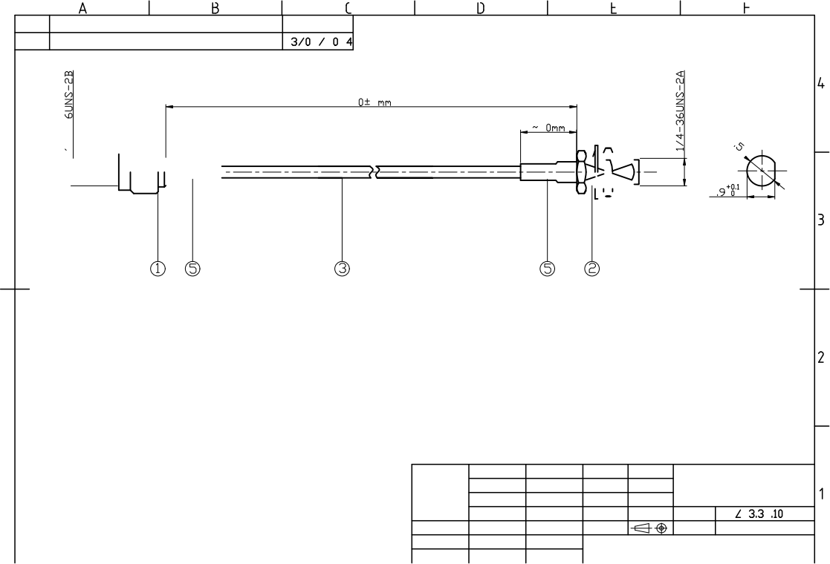
S
>一、______
RoHS Compliant.
Revision 新版发行
DATE
VER. V1.0
8 2 2
2

5 2

2

5

RECOMMENDED MOUNTING HOLE

1. SMA female CONNECTOR
2. SMA male CONNECTOR
3. 086 CABLE
4. HEAT SHRINK

TECH:
1.IMPADANCE: 50Ω
2.FREQUENCY: DC-8GHz
3. : VSWR≤1.5

SMA- male
1.CONDUCTOR: BRASS 2.INSULATOR: PTFE 3.BODY: BRASS,AU

4. INSERSION LOSS：≤0.35dB
MATERIAL&COATING: SMA male
g 2 : 1 01 cm²

1.CONDUCTOR: BRASS，AU 2.INSULATOR: PTFE
PN: GL3475-JYC

8 7
P/N
客户料号
, AU
日期: 日期: 日期:
TBD

3.BODY: BRASS,AU

V.S.W.R Testing
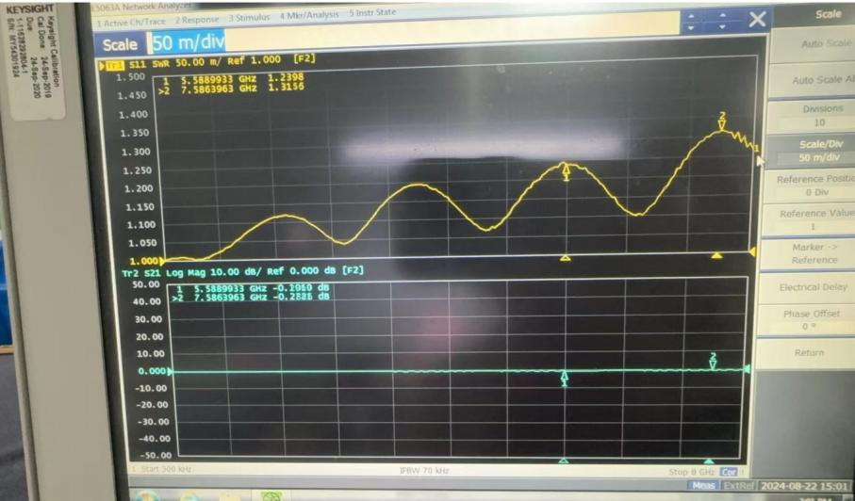

Product outline
