Product name: Handheld antenna
Product number:GL400S18
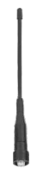

Item | Hand Held Antenna
PN | GL400S18
Frequency Range (MHz) | 400-470
Impedance (Ω) | 50
V.S.W.R | <1.5
Gain (dBi) | 2
Connector | SMA-K
Length-mm | 180
Weight | 14g

