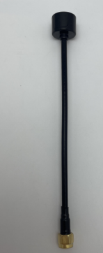

5.8G Antenna
GL5800-165
Electrical Index
Frequency-MHz | 5500-5800
Gain-dBi | 4.5-6
VSWR | ＜1.5
Normal Impedance -Ω | 50
Polarization | Liner
Mechanical Index
Cable Length | RG141 black
Connector | SMA male
Antenna Dimension-mm | Height 160mm
Vibration | 10 to 55Hz with 1.5mm amplitude 2hours
Environmentally Friendly | ROHS Compliant
Temperature-℃ | -40~＋85
Humidity-﹪ | 5~95

Drawing and testing VSWR

