Product name:Hand Held Antenna
Product number:GL805
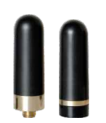
Item | Hand Held Antenna
PN | GL805
Frequency Range (MHz) | 144-430
Impedance (Ω) | 50
V.S.W.R | ≤ 1.5
Gain (dBi) | 2.5
Connector | SMA
Length-mm | 45
Weight | 45g

