Product name:Hand Held Antenna
Product number:GL806
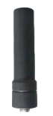
Item | Hand Held Antenna
PN | GL806
Frequency Range (MHz) | 824-960/1710-2700
Impedance (Ω) | 50
V.S.W.R | ≤ 1.5
Gain (dBi) | 2.5
Connector | SMA
Length-mm | 60
Weight | 56g

