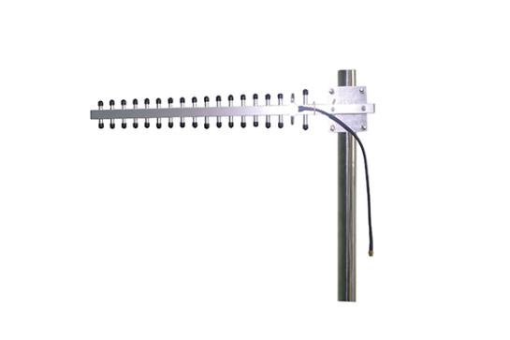
2.4GHz Yagi Antenna Product model：GLY2427V16
Applications：
* 2.4GHz/WLAN/WIFI System；
* Point-to-Point, Point-to-Multipoint Applications
Features：Small size, light weight and firm structure.

Electrical Specifications
Frequency Range | 2400-2700MHz
VSWR | ≤1.5
Gain | 16dBi
Horizontal beam width | 30°
Vertical beam width | 30°
Front-to-back ratio | ≥17dB
Polarization | V / H
Input Impedance | 50Ω
Maximum input power | 100W
Lightning protection | DC Ground
Mechanical Specifications
Input connector type | N-K
Installation | Pole-holding
Dimensions | 650×45×80mm
Antenna weight | 0.3kg
Radiating Element Material | AI
Operating temperature | -40°C to +70 °C

