Product name:868MHz Antenna
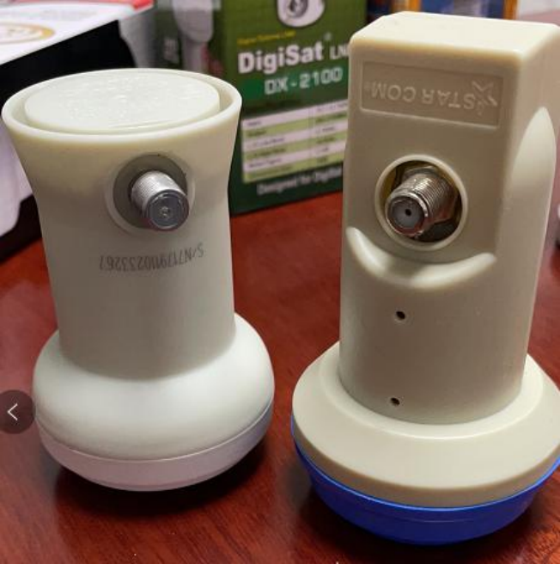
Product model:GLZ03-868
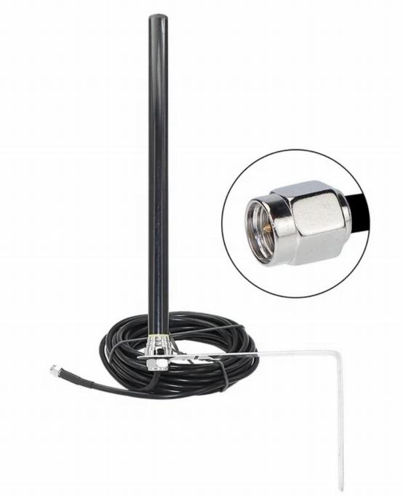

Frequency： | 868±10MHZ
Center frequency： | 868MHZ
GAIN： | 3.5dbi
VSWR： | <1.5
Polarization direction： | Vertical polarization
impedance： | 50Ω
Radiation direction： | omnidirectional antenna
Power Capacity： | 100W

l Structural parameters

Length of antenna： | 290mm
color： | Black
diameter： | Φ12mm
material： | PC/ABS
Inter face method： | SMA-J
operation temperature： | -40℃--﹢85℃
storage temperature： | -40℃--﹢85℃

Product Drawing
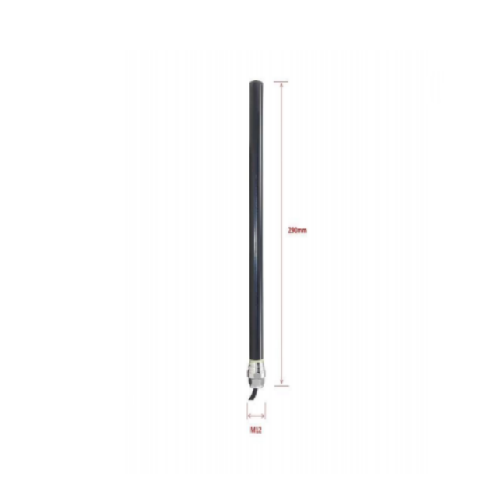

l Radio frequency performance testing
Test equipment: Satimo24G microwave laboratory+E5071C network analyzer

》Antenna OTA
Frequency（MHZ） | Efficency（%） | Gain（DBI）
858 | 50.08 | 3.08
860 | 50.11
862 | 50.29 | 3.31
864 | 51.17 | 3.37
866 | 52.14 | 3.46
868 |  | 3.52
870 | 53.07 | 3.46
872 | 52.89 | 3.44
874 | 52.35 | 3.39
876 | 51.83 | 3.32
878 | 50.98 | 3.29

》Antenna-S11

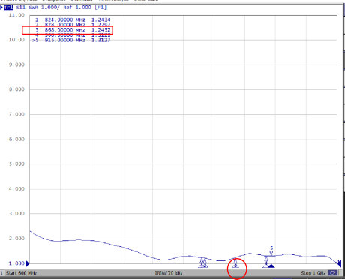
》Antenna 3D radiation pattern
