PRODUCT SPECIFICATION

MODULE NO. GX-M310
CUSTOMER

ISSUED DATE

CUSTOMER SIGNATURE BAR

CUSTOMER | ADMISSION | APPROVAL

Signed by Approved by

GX-M310

1. Product Information

1.1 Product Name

GX-M310

1.2 Product Description

GX-M310 is a compact, high performance, and low power consumption GNSS engine board. It uses the chipset which can track up to 66 channels at a time and perform fast TTFF in weak signal environments.

1.3 Product Features

MediaTek high sensitivity solution Support 99-channel GPS&BEIDOU
Ultra low power consumption Fast TTFF at low signal level
Built-in 12 multi-tone active interference canceller
Free hybrid ephemeris prediction to achieve faster cold start Built-in data logger
Built-in DC/DC converter to save power Up to 10 Hz update rate
±11ns high accuracy time pulse (1PPS)
Capable of SBAS (WAAS, EGNOS, MSAS, GAGAN) Support Japan QZSS
Indoor and outdoor multi-path detection and compensation Small form factor 10.1 * 9.7 * 2.5mm ±0.2mm
SMD type with stamp holes RoHS compliant

1.4 Product Application

Automotive navigation Personal positioning
Fleet management

1

GX-M310

Mobile phone navigation Marine navigation

2. Technical Specifications

 | GPS Receiver
Chip | MediaTek MT3333 (Flash Version)
Frequency | GPS, GALILEO, QZSS:L1 1575.42MHz, C/A code BEIDOU: B1 1561.098MHz
Channels | Support 99 channels
Update rate | 1Hz default, up to 10Hz
Sensitivity | Tracking | -162dBm, up to -165dBm (with external LNA)
Sensitivity | Cold Start | -143.5dBm, up to -148dBm (with external LNA)
Acquisition Time | Hot start (Open Sky) | < 1s (typical)
Acquisition Time | Hot start (Indoor) | < 30s
Acquisition Time | Cold Start (Open Sky) | 32s (typical) without AGPS
Acquisition Time | Cold Start (Open Sky) | < 15s (typical) with AGPS (hybrid ephemeris prediction)
Position Accuracy | Autonomous | 3m (2D RMS)
Position Accuracy | SBAS | 2.5m (depends on accuracy of correction data)
Max. Altitude | < 50,000 m
Max. Velocity | < 515 m/s
Protocol Support | NMEA 0183 ver 4.10 | 9600 bps, 8 data bits, no parity, 1 stop bits (default) 1Hz: GGA, GLL, GSA, GSV, RMC, VTG
 | Physical Characteristic
Type | 18 pin stamp holes
Dimensions | 10.1mm * 9.7 mm * 2.5mm ±0.2mm

3. Technical Information
Module Pin Assignment

2

GX-M310
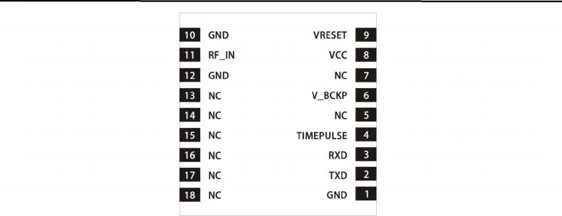

Pin NO. | Pin Name | I/O | Remark
1. | GND | G | Ground.
2. | TXD | O | Data Output
3. | RXD | I | Data Input
4. | TIMEPULSE | O | 1 Pulse per second
5. | NC | N | Not connected
6. | V_BCKP | PWR | Backup battery supply voltage
7. | NC | N | Not connected
8. | VCC | PWR | Main power supply to the engine board.
9. | VRESET | I | Reset
10. | GND | G | Ground.
11. | RF IN | RF | GPS antenna input
12. | GND | G | Ground.
13. | NC | N | Not connected
14. | NC | N | Not connected
15. | NC | N | Not connected
16. | NC | N | Not connected
17. | NC | N | Not connected
18. | NC | N | Not connected

Dimensions

3

GX-M310
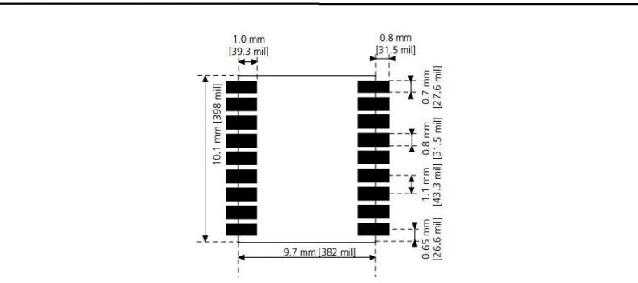

4. NMEA 0183 Protocol

The NMEA protocol is an ASCII-based protocol, Records start with a $ and with carriage return/line feed. GPS specific messages all start with $GPxxx where xxx is a three-letter identifier of the message data that follows. BEIDOU specific messages all start with
$BDxxx where xxx is a three-letter identifier of the message data that follows. NMEA messages have a checksum, which allows detection of corrupted data transfers.

GX-M310 modules support the following NMEA-0183 messages: GGA, GLL,GSA, GSV, RMC and VTG.

4.1 NMEA output message
Table 3.1-1 NMEA output message

NMEA | Description
GGA | Global positioning system fixed data
GLL | Geographic position - latitude/longitude
GSA | GNSS DOP and active satellites
GSV | GNSS satellites in view
RMC | Recommended minimum specific GNSS data
VTG | Course over ground and ground speed

4

GX-M310

4.1.1 GGA--- Global Positioning System Fixed Data
Table 3.1-2 contains the values for the following example:
$GPGGA,060406.000,2503.7148,N,12138.7451,E,2,17,0.71,116.7,M,15.3,M,0000,0000*6D
Table3.1- 2 GGA Data Format

Name | Example | Units | Description
Message ID | $GPGGA |  | GGA protocol header
UTC Time | 060406.000 |  | hhmmss.sss
Latitude | 2503.7148 |  | ddmm.mmmm
N/S indicator | N |  | N=north or S=south
Longitude | 12138.7451 |  | dddmm.mmmm
E/W Indicator | E |  | E=east or W=west
Position Fix Indicator | 2 |  | See Table 5.1-3
Satellites Used | 17 |  | Range 0 to 33
HDOP | 0.71 |  | Horizontal Dilution of Precision
MSL Altitude | 116.7 | mters
Units | M | mters
Geoid Separation | 15.3 | mters
Units | M | mters
Age of Diff. Corr. | 0000 | second | Null fields when DGPS is not used
Diff. Ref. Station ID | 0000
Checksum | *6D
<CR> <LF> |  |  | End of message termination

Table 3.1-3 Position Fix Indicators

Value | Description
0 | Fix not available or invalid
1 | GPS SPS Mode, fix valid
2 | Differential GPS, SPS Mode, fix valid
3-5 | Not supported
6 | Dead Reckoning Mode, fix valid

5

GX-M310

4.1.2 GLL--- Geographic Position - Latitude/Longitude

Table 3.1-4 contains the values for the following example: $GNGLL,2503.7148,N,12138.7451,E,060406.000,A,D*46
Table 3.1-4 GLL Data Format

Name | Example | Units | Description
Message ID | $GNGLL |  | GLL protocol header (GPGLL or GNGLL; GP  indicates the device receives GPS satellites signal only and GN indicates the position is calculated with BEIDOU satellite signal)
Latitude | 2503.7148 |  | ddmm.mmmm
N/S indicator | N |  | N=north or S=south
Longitude | 12138.7451 |  | dddmm.mmmm
E/W indicator | E |  | E=east or W=west
UTC Time | 060406.000 |  | hhmmss.sss
Status | A |  | A=data valid or V=data not valid
Mode | D |  | A=autonomous, D=DGPS, E=DR, N=Data not valid, R=Coarse Position, S=Simulator
Checksum | *46
<CR> <LF> |  |  | End of message termination

4.1.3 GSA---GNSS DOP and Active Satellites

Table 3.1-5 contains the values for the following example:
$GNGSA,A,3,22,21,18,12,24,25,14,15,193,,,,1.18,0.71,0.95*2C
$GNGSA,A,3,205,207,210,202,201,203,209,208,,,,,1.18,0.71,0.95*1C
Table 5.1-5 GSA Data Format

Name | Example | Units | Description
Message ID | $GNGSA |  | GSA protocol header (GNGSA or GPGSA; GP indicates the device receives GPS satellites  signal only and GN indicates the position is calculated with BEIDOU satellite signal).First row of GSA message contains GPS & QZSS satellites and second row of GSA message contains BEIDOU satellites.
Mode 1 | A |  | See Table 5.1-6

6

GX-M310

Mode 2 | 3 |  | See Table 5.1-7
ID of satellite used | 22 |  | Sv on Channel 1
ID of satellite used | 21 |  | Sv on Channel 2
N. |  |  | N.
ID of satellite used |  |  | Sv on Channel 12
PDOP | 1.18 |  | Position Dilution of Precision
HDOP | 0.71 |  | Horizontal Dilution of Precision
VDOP | 0.95 |  | Vertical Dilution of Precision
Checksum | *2C
<CR> <LF> |  |  | End of message termination
Table 3.1-6 Mode 1

Value | Description
M | Manual- forced to operate in 2D or 3D mode
A | Automatic-allowed to automatically switch 2D/3D
Table 3.1-7 Mode 2

Value | Description
1 | Fix not available
2 | 2D
3 | 3D

4.1.4 GSV---GNSS Satellites in View

Table 3.1-8 contains the values for the following example:
$GPGSV,4,1,13,19,81,216,46,03,71,010,45,27,63,031,45,23,52,245,44*7B $GPGSV,4,2,13,06,50,034,47,50,46,122,48,13,45,290,44,16,34,038,42*75 $GPGSV,4,3,13,11,28,184,35,07,15,320,35,07,15,320,35,31,10,124,39*73 $GPGSV,4,4,13,08,,,15*77
$BDGSV,2,1,08,08,79,307,38,07,73,100,40,10,70,345,37,03,65,190,39*6E $BDGSV,2,2,08,02,44,241,36,04,33,110,42,09,04,199,29,01,,,34*53
Table 3.1-8 GSV Data Format

Name | Example | Units | Description
Message ID | $GPGSV |  | GSV protocol header(GPGSVL or BDGSV; GP indicates the device receives GPS satellites  signal only and BD indicates the position is

7

GX-M310

 |  |  | calculated with BEIDOU satellite signal)
Total number of messages1 | 4 |  | Range 1 to 6
Message number1 | 1 |  | Range 1 to 6
Satellites in view | 13
Satellite ID | 19 |  | Channel 1 (Range 01 to 237), GPS Satellites  ID : 01~32,SBAS Satellites ID : 33~64, QZSS Satellites ID:193~196, &BEIDOU Satellites ID : 01~32
Elevation | 81 | degrees | Channel 1 (Range 00 to 90)
Azimuth | 216 | degrees | Channel 1 (Range 000 to 359)
SNR (C/No) | 46 | dB-Hz | Channel 1 (Range 00 to 99, null when not tracking)
N. | N. | N. | N.
Satellite ID | 23 |  | Channel 4 (Range 01 to 237) , GPS Satellites ID : 01~32,SBAS Satellites ID : 33~64, QZSS Satellites ID:193~196, &BEIDOU Satellites ID : 01~32
Elevation | 52 | degrees | Channel 4 (Range 00 to 90)
Azimuth | 245 | degrees | Channel 4 (Range 000 to 359)
SNR (C/No) | 44 | dB-Hz | Channel 4 (Range 00 to 99, null when not tracking)
Checksum | *7B
<CR> <LF> |  |  | End of message termination
1. Depending on the number of satellites tracked multiple messages of GSV data may be required.

4.1.5 RMC---Recommended Minimum Specific GNSS Data

Table 3.1-9 contains the values for the following example:
$GNRMC,060406.000,A,2503.7148,N,12138.7451,E,0.01,0.00,180313,,,D*78
Table 3.1-9 RMC Data Format

Name | Example | Units | Description
Message ID | $GNRMC |  | RMC protocol header (GNRMC or GPRMC; GP indicates the device receives GPS satellites  signal only and GN indicates the position is calculated with BEIDOU satellite signal)
UTC Time | 060406.000 |  | hhmmss.sss
8

GX-M310

Status | A |  | A=data valid or V=data not valid
Latitude | 2503.7148 |  | ddmm.mmmm
N/S Indicator | N |  | N=north or S=south
Longitude | 12138.7451 |  | dddmm.mmmm
E/W Indicator | E |  | E=east or W=west
Speed over  ground | 0.01 | knots | True
Course over  ground | 0.00 | degrees
Date | 180313 |  | ddmmyy
Magnetic variation |  | degrees
Variation sense |  |  | E=east or W=west (Not shown)
Mode | D |  | A=autonomous, D=DGPS, E=DR, N=Data not valid,R=Coarse Position, S=Simulator
Checksum | *78
<CR> <LF> |  |  | End of message termination

4.1.6 VTG---Course Over Ground and Ground Speed

Table 3.1-10 contains the values for the following example: $GPVTG,0.00,T,,M,0.01,N,0.02,K,D*3B
Table 3.1-10 VTG Data Format

Name | Example | Units | Description
Message ID | $GPVTG |  | VTG protocol header
Course over ground | 0.00 | degrees | Measured heading
Reference | T |  | True
Course over ground |  | degrees | Measured heading
Reference | M |  | Magnetic
Speed over ground | 0.01 | knots | Measured speed
Units | N |  | Knots
Speed over ground | 0.02 | km/hr | Measured speed
Units | K |  | Kilometer per hour

9

GX-M310

Mode | D |  | A=autonomous, D=DGPS, E=DR, N=Data not valid,R=Coarse Position, S=Simulator
Checksum | *3B
<CR> <LF> |  |  | End of message termination

4.2 Operating Modes
Send commands to select the different mode of operation.

Command | Operating Mode
PMTK353,0,0,0,0,1 | BD only mode
PMTK353,1,0,0,0,0 | GPS only mode
PMTK353,1,0,0,0,1 | GPS + BD mode

4.3 Proprietary NMEA input/output message
Please refer to MTK proprietary message.

4.4 Examples to configure the update rate of GNSS module
The GNSS module supports up to 10Hz update rate that user can configure by issuing software commands. Note that the configurations by software commands are stored in the battery-backed SRAM that is powered through VBACKUP pin. Once it drains out, the default/factory settings will be applied.
Due to the transmitting capacity per second of the current baud rate, GNSS module has to be changed to higher baud rate for high update rate of position fix. The user can use the following software commands to change baud rate.

Baud rate | Software command
default | $PMTK251,0*28<CR><LF>
4800 | $PMTK251,4800*14<CR><LF>
9600 | $PMTK251,9600*17<CR><LF>
19200 | $PMTK251,19200*22<CR><LF>
38400 | $PMTK251,38400*27<CR><LF>
57600 | $PMTK251,57600*2C<CR><LF>
115200 | $PMTK251,115200*1F<CR><LF>

10

