Model: HT-CPE500

OPENWRT 300Mbps Wireless N 4G LTE Router
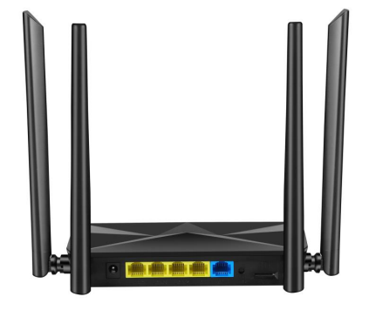
Features
● Cutting-edge 4G network - share internet access with up to 30 Wi-Fi devices and enjoy download speeds of up to 150 Mbps and Upload speed to 50Mbps
● Plug a SIM card and play - no configurations needed, compatibility of SIM cards in 100+ countries are assured by years of field tests
● Two advanced LTE antennas and Two WIFI antenna - enjoy stable and efficient connections to every device thanks to the two external antennas
● Wi-Fi router mode - plug an Ethernet cable into the LAN/WAN port for flexible access as a backup option if you can't get a 4G connection
Description
1) Support 3G, 4G LTE wireless network technology.
2) Support WCDMA, LTE TDD, LTE FDD Band.
3) Support SIM slot
4) 802.11n WiFi standard
5) 1* WAN port, 4* LAN ports
6) Support up to 30 users
7) 300Mbps WiFi

Spefication

Router hardware

 | Chipset | MT7628NN
 | Power input port | DC 12V---1A
 | WAN Port | 1 x RJ45(10BaseT/100BaseTX with Auto-MDIX IEEE 802.3/802.3u)
 | LAN Port | 4 x RJ45(10BaseT/100BaseTX with Auto-MDIX IEEE 802.3/802.3u)
 | WPS/Reset Buttons | Buttons: WPS ,Long press: reset(Used to restore the factory configuration of the router.)
 | Power button | Router's power switch (not required)
 | LED indication | 1,power supply 2,WIFI Indication  3,3/4G:green light indicates 3G, 4G status 4,WAN Interfaces;  5,LAN1; 6,LAN2; 7,LAN3 8.LAN4
 | Storage | SDRAM: 64MB  Nor Flash: 8MB
 | Wireless parameters
 | WIFI Frequency range |  | FCC: 2412-2462MHz(Ch1-Ch11)  ETSI: 2412-2472MHz(Ch1-Ch13)
 | Mobile network frequency |  | FDD: B1 B3 B5 B7 B8 B20 B28  TDD: B38 B39 B40 B41  WCDMA: B1 B8
 | Transmission rate |  | 11n:270/243/216/162/108/81/54/27Mbps 135/121.5/108/81/54/40.5/27/13.5Mbps 130/117/104/78/52/39/26/13Mbps  65/58.5/52/39/26/19.5/13/6.5Mbps
 |  |  | 11g:54/48/36/24/18/12/9/6M(Adaptive)
 |  |  | 11b:11/5.5/2/1M(Adaptive)
 | Number of working channels |  | 13
 | Spread Spectrum Technology |  | DSSS(Direct Sequence Spread Spectrum)
 | Data modulation method |  | BPSK, QPSK, CCK and OFDM (BPSK/QPSK/16-QAM/ 64-QAM)
 | Sensitivity @PER (error packet rate) |  | 270M:-61dBm@10% PER;130M: -61dBm@10%  PER;108M:-61dBm@10% PER;54M:-65dBm@10% PER;11M:-85dBm@8% PER;6M:-88dBm@10%  PER;1M:-90dBm@8% PER
 | Transmission distance |  | Up to 50 meters in the room and up to 200 meters in the outdoors (depending on the environment)
 | RF Power |  | 11n : 15±dBm;  11g : 17±1dBm;  11b : 19±1dBm(Typical value)
 | LTE related hardware
 | SIM Card Slot |  | Rear flip SIM card Slot
 | Antennas |  | External 4 antenna, corresponding to 4G main antenna, wifi dual antenna
 | Router software features
 | IP Address |  | Static or dynamic

 | PPP over Ethernet | YES
 | The maximum number of users | 32 (Simultaneous Internet access)
 | Routing Protocol | Static route, RIP1/RIP2
 | Configuration & Management | Based on WEB interface management (HTTP)
 | DHCP | Support Server and Client
 | Firewall protection | Built-in NAT firewall

